

SCHEDULE OF EVENTS

***RAFFLES***

* ***PRIZES***

•

* ***LIVE MUSIC***
* ***MAGICIAN***

ENTERTAINMENT

**8:30 am- Registration**

**9:30 am**- **Breakfast**

*(*omelet station & waffles)

**11:00 am- Shotgun Start**

(BBQ lunch at Halfway House)

Beverages will be available throughout

the day on the course.

**4:00 pm– Cocktail Reception (**open bar, raw bar, passed

hors d’oeuvres)

**5:00 pm- Dinner & Awards**

(Buffet Style Dinner)

*\*\*Subject to change based on COVID restrictions\*\**

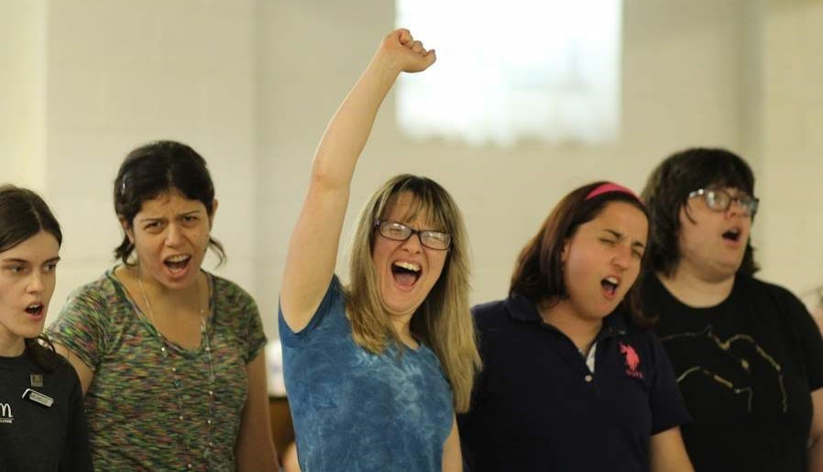

PBS COMMUNITY FOUNDATION

Now, more than ever, individuals with developmental disabilities are seeking the opportunity to stay in their communities, pursuing their personal goals while receiving the needed levels of support to make full community inclusion a sustainable reality.

What is often missing are community- based, grass-roots support networks, the interconnected social fabric that will secure life-long inclusion for individuals with disabilities as the basic human right that it is.

The **PBS Community Foundation** was established to help people with autism spectrum disorders, developmental disabilities, and other special needs with a particular focus on self-determination. Our mission is to help these individuals access the supports they need to become active and productive members of their communities and world.

PBS Community Foundation

P.O Box 263 Greenlawn, New York 11740

Pbscommunityfoundation.org

|  |
| --- |
|  |
| 5th ANNUAL |
| **PBS COMMUNITY FOUNDATION**  GOLF OUTING |
| JUNE 21, 2021 |
| HUNTINGTON  COUNTRY CLUB  483 MAIN STREET  HUNTINGTON, NY 11734 |
|  |

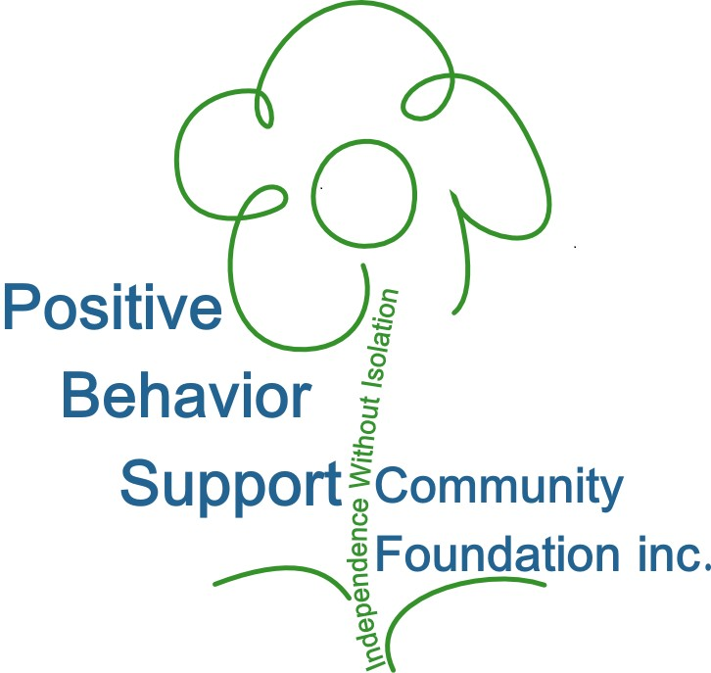

Event Chairs

John McLaughlin, Positive Broadcasting Support

John Innis,

Positive Behavior Support Consulting

Golf Committee

Sharin Borja, Courtney Braun, Diane M.C. Coleman, Diane Doherty, Shawn Gladstone, Brian Glascott, Elissa Grieco-Vetri, Roberta & Richard Grogan, Ruth-Ann Hartney, Barbara Maio, Kathy Mattera, Darlene Magito-McLaughlin, Tal & David Ourian, Ellen Proszak, Robin Rosenberg, John Spinelli, Jeff Tanen, Esq.

Committee Advisors: Theresa & Stephen Grieco

SPECIAL THANKS TO

SPONSOR

**DINNER SPONSOR:** $4,000

(Includes two foursomes, tee sign, flag & signage)

**GIVEAWAY SPONSOR:** $3,000

(Includes one foursome, tee sign & addl. signage)

**LUNCH SPONSOR:** $2,500

(Includes one foursome, flag & addl. signage) **BEVERAGE CART SPONSOR:** $500 **PUTTING GREEN SPONSOR:** $500

**FLAG:** $150 **TEE SIGN:** $200

**FOURSOME:** $2,000 **INDIVIDUAL GOLFER:** $525 **DINNER ONLY:** $150

|  |  |  |  |  |
| --- | --- | --- | --- | --- |
| REGISTRATION  REGISTER ONLINE AT PBSCOMMUNITYFOUNDATION.ORG OR USE THIS FORM | | | | |
|  | DINNER SPONSOR-   $4,000    GIVEAWAY SPONSOR-  $3,000   LUNCH SPONSOR- $2,500  | BEVERAGE CART- $500 |  | FOURSOME- $2,000 Qty: |
|  | PUTTING GREEN- $500  FLAG- $150 |  | INDIVIDUAL GOLFER-  $525 Qty: |
|  | TEE SIGN- $200 |  | DINNER ONLY- $150 |
| **PRINT YOUR NAME OR BUSINESS EXACTLY AS YOU WISH TO SEE IT IN ALL MATERIAL** | | | | |
| **NAME:** | | | | |
| **COMPANY**: | | | | |
| **ADDRESS**: | | | | |
| **CITY**: **STATE** _**ZIP** _ | | | | |
| **EMAIL**: **TEL:**( ) - | | | | |
| **PLEASE PROVIDE THE NAMES AND EMAIL ADDRESSES FOR ALL PLAYERS** | | | | |
| **1 NAME:** | | | | |
| EMAIL | | | | |
| **2 NAME**: | | | | |
| EMAIL | | | | |
| **3 NAME:** | | | | |
| EMAIL | | | | |
| **4 NAME:** | | | | |
| EMAIL | | | | |
| **MAKE PAYMENT TO:** PBS Community Foundation, PO Box 263 Greenlawn, NY 11740 | | | | |
| Positive Behavior Support Community Foundation, Inc. is a 501(c)3 organization. | | | | |